January 2013 | Tallahassee, Florida | For more information contact:  Suzanne Hurst – 850-222-6000

Visit www.YourAssociationShortcut/press for contact details, review copies, photos and an author bio.
How Some “Lucky” Companies Are
Getting Customers Through Associations

New book released: The definitive guide to marketing through associations

Thousands of businesses are marketing through associations, at events, tradeshows and through member benefit programs. However, there’s never been a book that reveals the right way to do it, how to speed up the process and how to generate more customers through associations. For many, association marketing is slow, frustrating and expensive. For others, those who have been lucky enough to discover the association marketing insider’s secrets, it’s a scalable marketing media that works 52 weeks a year, is more trackable than social media and generates a terrific return on investment.

“Associations are the affiliate partner you never knew you had, promoting your company as a member benefit,” says Robert Skrob, CPA, CAE, author of the book Your Association Shortcut. “Plus, association marketing gives you more credibility as everything you do carries the implied endorsement of the association.”

Mr. Skrob has consulted with companies that market through associations for more than 20 years. Now he has authored a book to answer the 75 most common questions he receives about marketing through associations. This groundbreaking book is called Your Association Shortcut. In this book Mr. Skrob reveals why most marketers get stopped before they ever get a chance to create endorsed member benefit programs with associations. He shows marketers the best ways to approach an association and how to speak with the association’s leaders and staff. He even shares where to find associations for marketers who don’t believe there is an appropriate association for them to market through.

Robert Skrob has more than 20 years of experience in the association industry, helping associations grow their memberships through better benefits, communication and systems. Under his leadership, several associations have grown to represent over 90 percent of the potential members within their industries. Throughout his career, Mr. Skrob has worked with hundreds of companies to market and promote their products and services to members of associations.

Mr. Skrob has produced a free 20-minute training video titled 5-Easy Ways to Solve the 7 Biggest Marketing Problems by Marketing Through Associations. This video is available for anyone to watch at www.YourAssociationShortcut.com.

-ENDS-
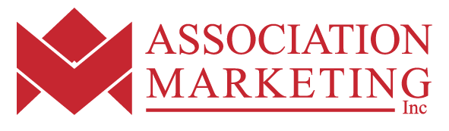 | 1390 Timberlane Road  Tallahassee, FL 32312  Phone: 850-222-6000  Email: Suzanne@HelpMembers.com  www.YourAssociationShortcut/press

